QESST New Student Handbook

2019-2020

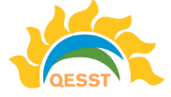

Table of Contents

Introduction . . . . . . . . . . . . . . . . . . . . . . . . . . . . . . . . . . . . . . . . . . . . . . . . . . . . . . . . . . . . . . . . . . . . . 3
QESST and SLC Overview. . . . . . . . . . . . . . . . . . . . . . . . . . . . . . . . . . . . . . . . . . . . . . . . . . . . . . . . . . . 3
Research – How It All Fits Together. . . . . . . . . . . . . . . . . . . . . . . . . . . . . . . . . . . . . . . . . . . . . . . . . . . 4
QESST Research Faculty and Area. . . . . . . . . . . . . . . . . . . . . . . . . . . . . . . . . . . . . . . . . . . . . . . . . . . . 5
QESST Administrative Faculty. . . . . . . . . . . . . . . . . . . . . . . . . . . . . . . . . . . . . . . . . . . . . . . . . . . . . . . . 7
QESST All-Calls and Thrust Calls. . . . . . . . . . . . . . . . . . . . . . . . . . . . . . . . . . . . . . . . . . . . . . . . . . . . . . 7
Journals and Conferences. . . . . . . . . . . . . . . . . . . . . . . . . . . . . . . . . . . . . . . . . . . . . . . . . . . . . . . . . . . 8
Site Visit. . . . . . . . . . . . . . . . . . . . . . . . . . . . . . . . . . . . . . . . . . . . . . . . . . . . . . . . . . . . . . . . . . . . . . . . . 8
Outreach. . . . . . . . . . . . . . . . . . . . . . . . . . . . . . . . . . . . . . . . . . . . . . . . . . . . . . . . . . . . . . . . . . . . . . . . 9
Awards and Professional Development. . . . . . . . . . . . . . . . . . . . . . . . . . . . . . . . . . . . . . . . . . . . . . . 11
Diversity. . . . . . . . . . . . . . . . . . . . . . . . . . . . . . . . . . . . . . . . . . . . . . . . . . . . . . . . . . . . . . . . . . . . . . . . . 11
Student Support . . . . . . . . . . . . . . . . . . . . . . . . . . . . . . . . . . . . . . . . . . . . . . . . . . . . . . . . . . . . . . . . . 12
Conclusion . . . . . . . . . . . . . . . . . . . . . . . . . . . . . . . . . . . . . . . . . . . . . . . . . . . . . . . . . . . . . . . . . . . . . . 12

Introduction

QESST is an organization that links solar research between eight US universities: Arizona State University, University of Delaware, California Institute of Technology, University of Houston, Georgia Tech, University of Arizona, University of New Mexico, and Massachusetts Institute of Technology.
This handbook covers areas of QESST and the Student Leadership Council (SLC) that are useful to know for the summer 2019 – summer 2020 year. All students, including undergraduates, graduate students and possibly postdocs, should read each section to familiarize themselves with the QESST organization and SLC. Links will be provided where necessary in each section, but bear in mind some may become out of date as the year goes on. You can refer to the QESST website – qesst.org – or contact QESST’s email qesst.slc@gmail.com with further questions.

QESST and SLC Overview

Quantum Energy and Sustainable Solar Technology (QESST) is a multidisciplinary, multi-university organization with a focused vision of advancing solar cell technology further along the path to providing terawatt levels of energy worldwide. It is a National Science Foundation (NSF) Engineering Research Center (ERC), of which there are approximately 20 others around the United States all focusing on various grand challenges facing the world today. Engineering Research Centers run for 10 years total, and 2019-2020 is Year 9 of the QESST program. QESST leadership are working on plans to continue the collaboration forward past year 10 in what is known as the “Transition Plan.”

The Student Leadership Council (SLC) is composed of students throughout QESST. The SLC’s function is to provide a support network for students through events such as career fairs, retreats, online webinars, outreach events, and many more. Every student in QESST is considered part of the SLC, even if they don’t hold a leadership position. The current SLC Co-Presidents are Nick Irvin and Kelly McKenzie.

Co-President – Nick Irvin
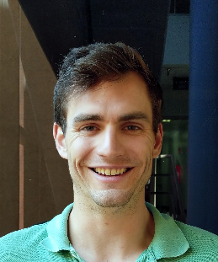
Nick is a 3rd-year physics PhD student at Arizona State University. His advisors are Dr. Honsberg and Dr. King. His research includes the following simulation of the limiting efficiencies of solar cells, characterization with XRD, TRPL, AFM, and Hall, and MBE growth of carrier selective contacts with low doping concentrations. Nick won last year’s 1,000-word challenge at QESST.

Co-President – Kelly McKenzie
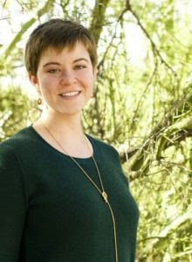
Kelly is a 3rd year materials science student at Caltech working with Dr. Atwater. Her research centers on effectively transparent contacts (ETCs) for reduced shading due to contact grids on optoelectronic devices. She develops fabrication techniques as well as optimizing grid geometries and device structure to best utilize ETCs. Kelly’s goal as co-president is to increased partner-university student involvement in QESST-sponsored activities.

Research – How It All Fits Together

As an incoming student, it can be confusing to determine how your project fits with the rest of QESST. Fortunately, there is the “3-Plane Diagram,” shown below, that gives a framework of the scope of research covered by the QESST organization. It is highly recommended, whether you have decided on a professor or not, to refer to this diagram when discussing potential new projects with your PI.

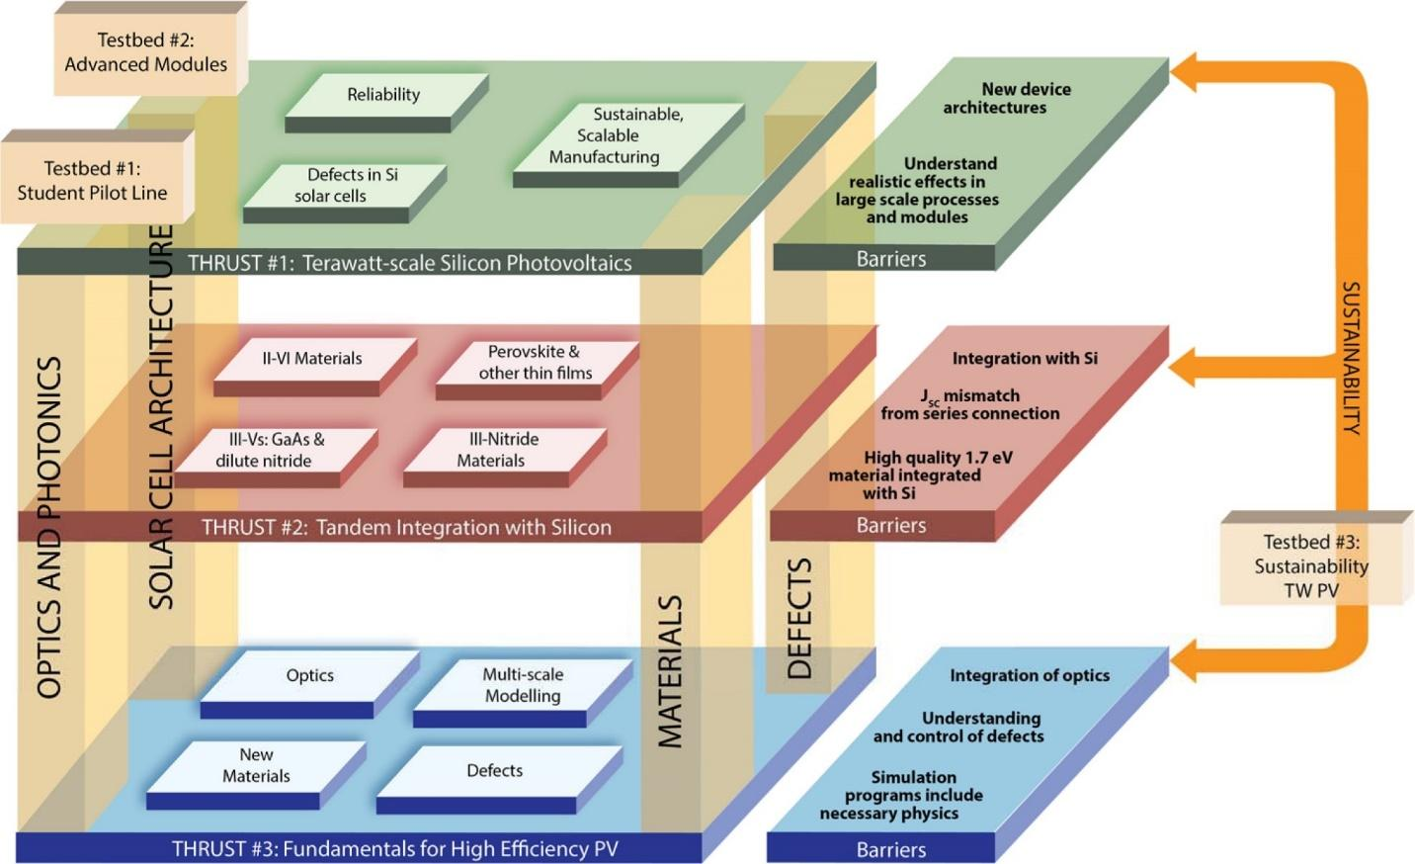
Figure 1: 3-plane diagram depicting the large range of QESST research topics.

The 3-plane diagram is composed of the research tiers Thrust 1, Thrust 2, and Thrust 3 and the three testbeds Testbed 1, Testbed 2, and Testbed 3. Thrust 1 focuses on technology that is either in industry currently or very close to being industry-ready and improving that. Thrust 2 looks at up-and-coming, promising technologies such as Si tandems that may be industry ready in the future but have some significant barriers that need to be overcome in order to accomplish this. Thrust 3 looks at unique technologies that are considered high risk and high reward. These technologies have the potential for extremely high efficiencies at very low costs, but are many years away from being viable and have many significant hurdles that must first be overcome.

Testbed 1 focuses on the solar-cell pilot lines within QESST. ASU has a large silicon pilot-line that can take bare silicon wafers and transform them into fully functional modules, with each step run entirely by students. MIT has a module pilot line as well for silicon solar cells, and the University of Delaware has a thin film pilot line. The pilot-line can be used as a testing ground for novel technologies.

Testbed 2 focuses on modules, systems, and integration of solar into the grid. This testbed is power-engineering focused and is geared toward the development of integrated sensors, DC-DC converters, and DC-AC integrated inverters and controllers for efficient power transfer of PV modules.

Testbed 3 focuses on sustainability pathways for photovoltaics development. This testbed encompasses many different projects within Thrust 1, Thrust 2, and Thrust 3, with the common theme of making photovoltaics as sustainable as possible, as well as developing the tools and analysis techniques to measure sustainability reliably as more and more photovoltaics are deployed around the world.

It is common for students to be unsure of the difference between thrusts and testbeds when joining QESST. To put it succinctly, every QESST project will fall under a thrust. These describe the overall research focus of the project. These projects may or may not also involve a testbed. In the 3-plane diagram, you can see that currently all Testbed 1 and Testbed 2 projects are also Thrust 1 projects. However, Testbed 3 can encompass any of the three thrusts due to its broad nature and applicability.

Every year, QESST adjusts the funding allocated to each project. Each professor is different in what they expect from students for the project proposals. While some professors prefer to write the proposal themselves and simply ask their students for their data and graphs, other professors will ask you to write the proposal and they will simply look it over and provide some edits. It is important to discuss with your professor about the level of involvement they expect from you for these proposals.

QESST Research Faculty and Area

Thrust 1: Large-Scale Silicon
- Bob Opila (Lead, U Delaware)
- Harry Atwater (Caltech)
- Stuart Bowden (ASU)
- Stephen Goodnick (ASU)
- Christiana Honsberg (ASU)
- Zachary Holman (ASU)
- Govindasamy Tamizhmani (ASU)
- Dragica Vasileska (ASU)
- Mariana Bertoni (ASU)

Thrust 2: Silicon-Based Tandems
- Zachary Holman (Lead ASU)
- Alan Doolittle (Lead, Georgia Tech)
- Harry Atwater (CalTech)
- Ganesh Balakrishnan (UNM)
- Stephen Goodnick (ASU)
- Christiana Honsberg (ASU)
- William Shafarman (U Delaware)
- Alexandre Freundlich (UH)
- Fernando Ponce (ASU)
- David Smith (ASU)

Thrust 3: Fundamentals to Higher Efficiency
- Steve (Lead, ASU)
- Alex Freundlich (Lead, U Houston)
- Harry Atwater (CalTech)
- Robert Birkmire (U Delaware)
- Christiana Honsberg (ASU)
- Ganesh (Gunny) Balakrishnan (UNM)
- William Shafarman (U Delaware)
- Mariana Bertoni (ASU)
- Fernando Ponce (ASU)
- David Smith (ASU)
- Zachary Holman (ASU)
- Alan Doolittle (GaTech)
- Robert Opila (U Delaware)
- Raymond Kostuk (UA)
- Dragica Vasileska (ASU)

Testbed 1
- Stuart Bowden (Lead, ASU)
- Mariana Bertoni (ASU)
- Tonio Buonassisi (MIT)
- Zachary Holman (ASU)
- Christiana Honsberg (ASU)
- Robert Opila (U Delaware)

Testbed 2
- Mariana Bertoni (Lead, ASU)
- Govindasamy ‘Mani’ Tamizhmani (ASU)
- Stuart Bowden (ASU)
- Ray Kostuk (U Arizona)

Testbed 3
- Sarah Kurtz (Lead Merced)
- Christiana Honsberg (ASU)
- Tonio Buonassisi (MIT)
- Stuart Bowden (ASU)

Education, Diversity, & Sustainability
- Michelle Jordan, Education Director (ASU)
- Delia Saenz, Diversity Director (ASU)
- Tiffany Rybiski, Education & Outreach Coordinator (ASU)
- Stefi Weisburd, Education & Outreach Program Manager – (UNM)
- Clark Miller, Sustainability Director (ASU)

QESST Administrative Faculty

Throughout the year you will receive emails from Robert Sampson (Bob) and Katherine Taylor (Katie) about various QESST events, such as All-QESST and Thrust calls, outreach events, and site visit details. Go ahead and email Katie at Katherine.Taylor55@asu.edu so that she can add you to the Project Center Website.

QESST All-Calls and Thrust Calls

Soon after joining QESST, your name will be added to several email lists depending on your research topic. The meeting dates and timings should be available in the monthly newsletter (if you don’t get that then email Katie). Attend them to better understand how QESST functions and where your project may fit in to the larger scope of research being conducted. Each “All-Call” and “Thrust” meeting occur once a month. The All-Call meeting is a meeting between everyone in QESST, including students and faculty across all universities. These calls are made to be very easy to join - you just open the link in the email. Many people choose to turn off their video feed. There is also an option to call-in on your phone, though you won’t be able to see the slides being presented. This is generally the most administrative-heavy meeting, but you are highly encouraged to attend when possible, as it provides great insight into QESST and upcoming events as well as keeps the organization running.

The Thrust call meetings are similar in scope to the all-call meeting, but only include those within your given Thrust area. Due to the dual nature of many projects, students sometimes opt to participate in multiple thrust meetings to keep up-to-date on similar research projects. In these meetings, there are generally 1-2 student presenters who showcase their most exciting results while also receiving advice from others within the thrust. Even if you are not currently working on a project in a specific thrust, you are still welcome to join that thrust’s monthly call if you would like.

Journals and Conferences

QESST encourages its students to always be looking for ways to share their research through conferences and publications. Major publications to look towards submitting towards are IEEE Journal of Photovoltaics, Progress in Photovoltaics, and Nature Energy. Journal publications are more prestigious but more exclusive than conferences. When you get a paper on solar cells accepted to any peer-reviewed journal, make sure to enter that information at https://drive.google.com/open?id=1LFYxb1EJRS8OkRbw_I-baxavrqZhe9BV. The number of publications is a key metric for the success of QESST as an ERC.

There are two conferences that receive the most QESST students: PVSC and MRS as discussed below. All QESST students should try to attempt PVSC, and students with projects with a material science focus should also attend MRS.
Photovoltaics Specialist Conference (PVSC): This conference focuses on all different types of solar technologies. Its location changes each year, but most recently it has been in Portland, Hawaii, and Chicago. PVSC 2020 will be held in Calgary, Canada. The conference generally takes place in early-mid June, and abstract submissions are due around January. An important feature of this conference is that the top papers can be selected for journal publication in Journal of Photovoltaics.
Materials Research Society Conference (MRS): This is a more general conference that is very large, but there usually is solar-related sections within the conference. There is a spring conference that takes place in Phoenix in April, and a fall conference that takes place in Boston at the end of November. The spring conference has historically targeted solar topics more than the fall conference.

Be sure to look for smaller conferences that may fit your research more closely as well such as NAMBE, AZSEC, and SPIE. Weeks before the conference, be sure to ask your supervisor for any paperwork that may be required for reimbursement. At ASU, students should submit a trip request on ‘Concur’ before the conference and then re-verify the request on ‘Concur’ after the conference in order to get paid for conference expenses. ASU students can talk to their supervisor or Katherine Taylor at Katherine.Taylor55@asu.edu for more information.

Site Visit

Each year during early May, QESST has a site visit at ASU. We are visited by a team from our sponsoring agencies, the National Science Foundation (NSF) and the Department of Energy (DOE). They review each project and aspect of QESST, including research projects, outreach, diversity and a variety of other topics. While a lot of the work for this is on the professors’ side, the NSF team is always very interested in what students have accomplished and everyone’s specific research. Therefore, it is important to treat this like a conference. Each student that receives funding from QESST is typically expected to present a poster on their research during the site visit. Continued QESST funding partially depending on the quality of this poster session. Speak with your faculty about whether you will be attending and presenting early so that you can be prepared.

The site visit is a valuable way to network with other photovoltaic scholars in your network. Make your best effort to attend, especially as a new student. Details for preparing the poster will be emailed in early spring. To give some sense of what is covered during the site visit, go to www.qesst.org and go to the Resources Tab and then to Site Visit on the sidebar and you can see last year’s Full Agenda document. If the information is not visible you can email qesst.slc@gmail.com.

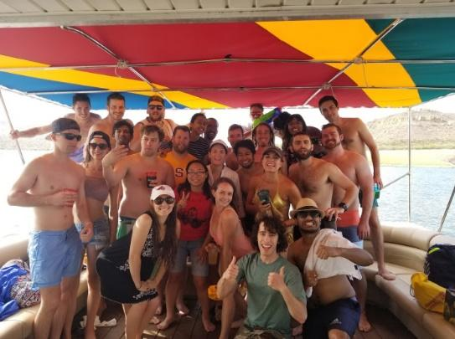
And last but not least, there is always a student retreat during the weekend before the site visit that everyone is encouraged to attend. This has been a party boat trip on a lake in Arizona. During this time, we talk about the upcoming site visit and the successes and challenges of the SLC during the past year, and then we spend a large part of time partying! While this event is obviously not mandatory, we still strongly encourage people to attend, as it is this time when most people can meet and get to know students from other schools and other labs. There are many students in QESST who can’t swim as well, so don’t let that stop you from joining us, as the boat is quite large and there are always plenty of life jackets!

Outreach
QESST faculty, staff and students are strongly committed to community outreach. Our goal is to develop and create strong and engaging relationships with title one schools and members of the local community while providing graduate students with opportunities for hands-on learning and working experiences. Engaging graduate students in K-12 outreach benefits both the K-12 student as well as the graduate student by directly increasing young students’ awareness of scientific research in photovoltaics and is also a valuable opportunity for the graduate student to improve their scientific communication and mentoring skills. As a graduate student, could you explain your research to a 12-year-old so that they could understand it? Students that receive QESST funding must participate in an outreach event every semester. Do at least 1 per semester.

Tiffany Rybiski is the outreach coordinator and is located at ASU. You can reach out to her if you have any questions or concerns at Tiffany.Rybiski@asu.edu. Another resource that is available at the University of New Mexico is Stefi Weisburd. Stefi is the Education and Outreach Program Manager at UNM. She can be reached at weisburd@unm.edu. Nick Valdes is a student at the University of Delaware that has experience setting up independent outreach events. You can contact Nick V. at nhvaldes@udel.edu.

The following paragraphs are a message from the Outreach Coordinator, Tiffany Rybiski:

QESST has a robust outreach program! Most of the events we host are with partner schools. Our partners are Phoenix Union, Alhambra Elementary, Kyrene Elementary, and the MESA program (this is another outreach program that we cosponsor). With many of the schools that we partner with we assist K-12 teachers throughout the year to help further solar education. Many of them have also participated in our summer RET program, in which they come to the lab and get hands-on solar experience. We participate in large community events as well for example, ASU Homecoming and Open Door. These events draw huge crowds! Also, QESST scholars across our universities have opportunities to participate in virtual outreach through a Virtual Lab Tour activity at an annual STEM Saturday event, and through our QESST PVSC High School Competition mentoring program.

Do you need experience to participate? NO! Often, just your presence is enough. The impact that our grad students have on K-12 students just by showing up is evident. Many of these students will be the first in their family to attend college. When you sign up, I will share the plans with you for the event and you can decide how you would best fit into the lesson. Teaching, assisting, the option is totally up to you. The only thing I ask is that you show up on time with a smile on your face!

Where do I sign up for events? There is a google doc with all the events (that I know of so far) listed. The link is listed below. Can I do an event that is not listed? Absolutely, and if you need any help planning it Michelle Jordan, the QESST Education Director, and I are here to assist! We have an outreach handbook (the link is below) of lessons that you could use OR just let us know what your intended lesson is and we can help you with the materials and supplies!

Is this a requirement? Yes! In order to receive funding from the NSF, QESST is required to participate in outreach (across all of our partner universities). We ask that every scholar signs up for just 2 events each year at a minimum.

Outreach links:

Sign up here to participate in outreach events at ASU: https://docs.google.com/spreadsheets/d/1f-mUibem1n_fA2m8zF6hKrw1BPtTDTvFKN3icyfSyiY/edit?usp=sharing

QESST has many resources available for use that have been classroom or tested with the public. The first is the Solar Outreach Activities Handbook that is available online and as a hard copy. The handbook has outreach activities that can be used at campus events (homecoming) or large public events (earth day, or energy day). Additionally, the handbook has classroom lessons that have been written by teachers and tested with their students. Outreach handbook link: https://qesst.org/education-and-outreach/

The second outreach resource is the QESST Dropbox folder. The Dropbox folder contains videos, PowerPoints, and other activities that have been used by all of our QESST partners. The Dropbox can be located here: https://www.dropbox.com/sh/23xo23yf971u9e3/AADt_EeeuCveuTCwhZtFoHBpa?dl=0

Awards and Professional Development
QESST provides opportunities for professional development through competition and mentoring opportunities. We are going to introduce a new award for best publication. In the past we have had the following:
- Perfect Pitch, a 90-second presentation of a novel idea for solar cells. Participants pitch their idea to QESST’s industry board. Winners go on to compete in the prestigious national competition in front of members of the US congress. Contact Jon Mitchell at John.J.Mitchell@asu.edu.
- QESST Excellence in Outreach Award. Contact Tiffany Rybiski at Tiffany.Rybiski@asu.edu.
- Mentor two students for the Research Experience for Undergraduates (REU) program during the summer. You could win the Outstanding Mentor Award for this. Contact Michell Jordan at michelle.e.jordan@asu.edu.
- Check with your PI for opportunities for internships in national and foreign internships with national labs and industry partners.

Diversity
QESST is committed to increasing diversity and broadening participation in STEM (science, technology, engineering and mathematics) by people and groups that are underrepresented in these fields. From its outset, QESST adopted a framework of ‘Inclusive Pedagogy’ as its strategy for promoting a culture of inclusion. This framework focuses on building awareness, understanding, and effective practices related to broadening participation of women, ethnic/racial minorities, and persons with disabilities. Our collective efforts have spanned Center function areas by having faculty, students and staff engaged in activities such as: education training on diversity, outreach to underserved populations, public education (across multiple language groups via PVEducation.com), development of community partnerships (including grant proposal submissions) and collaboration with other ERCs on recruitment and diversity. A video of Dr. Saenz’s, Arthur M. Sackler Colloquia of the National Academy of Sciences, Pressing Questions in the Study of Psychological and Behavioral Diversity, was posted to the QESST website.
QESST faculty and students have been part of the Capacity Building Institute (CBI) offered by AccessERC, where they have learned strategies and exchanged ideas for recruiting and supporting individuals with disabilities. As a result of this learning experience, we are striving to make our website accessible to everyone. We are working on providing text descriptions of images and video clips, making our content formatted for screen reader apps and hardware, as well as making our content accessible by using the keyboard alone. Suggestions for increasing the accessibility of these pages are welcome.
Support for New Students
The QESST SLC keeps an archive of videos and PowerPoints from past webinars. For instance, among these resources, you can find information from our book study about mentoring underrepresented students in STEM, our leadership workshops, and our webinar series on Thriving in Graduate School. These are located at
https://qesst.org/resources/webinars/ with password QesstWebinars.
QESST students at ASU should have access to rooms ERC 106, 181, and 189 by following https://drive.google.com/open?id=1mX1pSM3P5fJ8a_zCMC4t1jVDmTdQZDCG.

Can’t Resolve an Issue with your PI?

Throughout your research, there may be times when you need some outside help to resolve an issue with your advisor. QESST has a designated faculty member, Michael Goryll, who you can go to with any questions or concerns you may have. Dr. Goryll is the QESST Student Liaison. This can also be completely anonymous. Do not worry that this may reflect in any negative way on you, as many students, even the most successful within QESST, have utilized this service many times for a wide-range of issues. You can reach him at: Michael.Goryll@asu.edu

Conclusion

I hope this packet gives you a general sense about what QESST is and how you may fit into our organization. If you have any questions please feel free to email the QESST SLC at qesst.slc@gmail.com, or speak to your professor and other students within QESST. A great place to find more detailed information is www.qesst.org.

