Solar Outreach Handbook 21
At the University of New Mexico (UNM), QESST students and the outreach manager demonstrate one way electricity generated by a solar panel can power a residential system using a demo board designed and built at UNM based on similar projects found on the web. The main components of the board are a solar panel, a charging controller, battery, inverter and a variety of loads including a DC-driven computer fan, different kinds of light bulbs and a USB charger located in the inverter.

In normal operation, electricity from the solar panel flows to the charging controller, which limits the amount of solar current charging a 12-volt lead-acid battery (an older type of battery that is used in vehicles) and prevents electricity from flowing back to the solar panel at night or in low light conditions from the battery. The LEDs on the charging controller indicate the charge state of the battery (the three red LEDs), if the battery is being charged and whether 12VDC is available for the load. There is also a switch that allows the user to manually bypass the charge control system and power the rest of the board directly from the solar panel. There are additional switches to control current flow among the loads: (1) turns the DC fan on/off; (2) turns on and off the rest of the board, which consists of two sets of lights – one set runs on DC power and includes an incandescent bulb, LED and halogen bulb, and the other set runs on 120 volts AC from the inverter and powers an incandescent and CFL bulb. The intent was to choose sets of bulbs of comparable brightness, so students could compare the power usage of different bulb technologies. There are also three access points to take multimeter voltage measurements: (1) at the solar panel before the charge controller, (2) across the battery, and (3) across the loads. The latter point also allows for current measurements, and current can also be measured at the solar panel by placing a multimeter in series with the panel.

Here are some guiding questions to elicit the main ideas of this demo:

1. Set the switch to Solar Panel Only, and turn off all the loads. Using the multimeter measure the voltage of the current coming out of the solar panel. Is it direct current (DC) or alternating current (AC)? [DC] What kind of current do you use in your house? [AC] Most appliances are designed to receive AC. What would you have to do to the solar current in order to use it in your house? [Change it to AC – that’s what the inverter does]. Why do you think your house uses AC? [AC allows utilities to transmit electricity for long distances from the power plant to houses at high voltages and low current, which results in much lower energy losses due to resistance than does conventional DC. It is much easier to change the AC voltage than the DC voltage because of AC devices called transformers that “step up” the voltage for transmission and then “step down” the voltage to safer levels, around 120 volts, at your house.

2. See what happens to the voltage and current of the solar panel when you tilt it at different angles relative to sun. What orientation produces the most volts, amps, power (P=I*V)? [Perpendicular to the sun]. Try covering half of the panel along the vertical axis, then the horizontal axis, then diagonally. What happens? [Should get less power, but exact decrease depends on how the array is configured].

3. Measure the voltage of the solar panel at the solar panel access point, but turn the switch to the entire charging system. Do you get the same result you got in #1? [Not unless the solar panel is putting out 12 volts, plus in our particular system the charging controller also acts as a load, limiting the voltage to 12 volts.] Why do you think this is? [The charging system keeps the voltage at a fairly steady 12 volts. You can’t rely on the solar panel voltage all the time because it varies widely depending on the sun. The charging controller regulates the system, and the battery acts as a buffer voltage when needed. Also our solar panel is rated at 20 volts, which is too high for some of our load components such as our LED bulb so we must restrict the voltage.]

4. Measure the voltage across the battery. Is it the same as that of the solar panel voltage in #1? [Not unless the solar panel puts out 12 volts]. Is it AC or DC? The battery is rated at 12 volts DC. Do you measure 12.0 volts exactly? [No, in real circuits voltages may vary and devices are designed to operate within a given range].

In our system, the battery is rated at 2.5 amp-hours and the solar panel is rated at 1 amp/20V. If the solar panel is fully illuminated, how long should it take to charge a fully discharged battery? [The controller will only charge the battery at about 12V, so it will limit the solar panel to 12V, 1 amp of charging power. Thus it should take about 2.5 hours to fully charge a discharged battery]

5 At the load access point, make a table of the current and voltage measurement you get for each element on the board individually, i.e., DC fan, DC LED, DC incandescent, DC halogen, AC CFL, AC Incandescent bulb. Calculate the power each element consumes. Which is the most efficient of the DC lights? [LED] Which light is the most hot to touch? [Incandescent] Is all the power of the incandescent going to make light? [No, some of it is generating heat, making it less efficient]. The LED light uses less energy. Does that mean it is dimmer than the other bulbs? [No it is very bright.] We use lumens to denote the brightness of bulbs. These DC lights can have the same number of lumens, but use different amounts of power in watts. Which of the AC lights uses less power [CFL].

6. The DC set of bulbs seem to work fine on direct current and about 12 volts. In fact LEDs are designed to run on low voltage (12-24V), DC electricity. (Incandescent lights can operate on AC or DC at a wide range of voltages). Since the incoming electricity in most buildings is at higher voltages (120-277V) and AC, what do you have to do in order to use an LED bulb in your house? [Use a special driver to “rectify” the incoming high voltage, AC current to low voltage, direct current]. Can you think of a situation where it might be more efficient to use LEDs, solar panels and batteries alone? [Off the grid homes or camping, where the solar cell and battery are the chief power supply of DC current and no conversions are necessary].
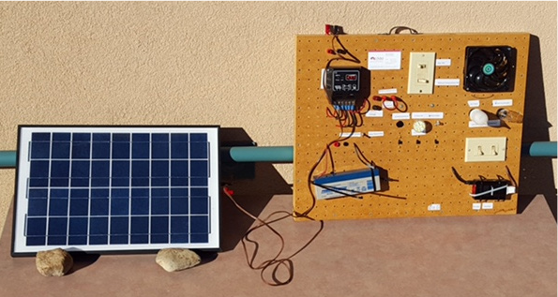
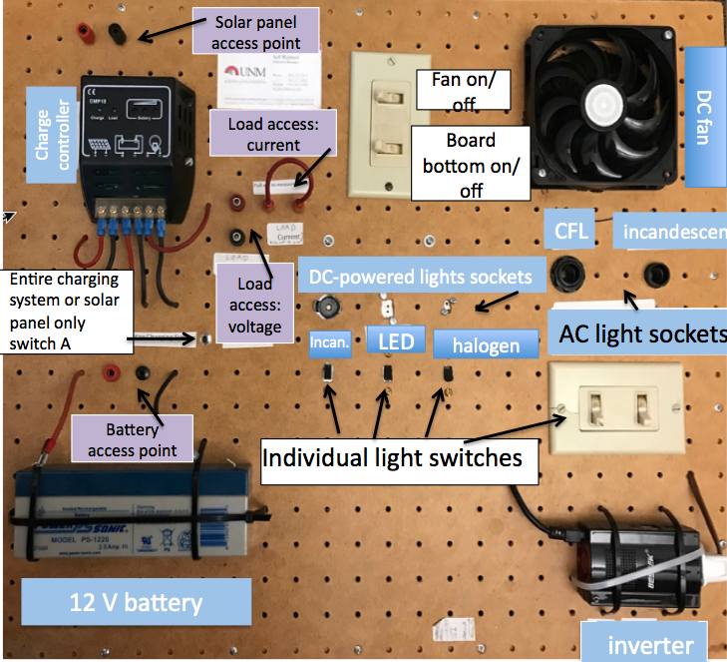

IF YOU DON”T HAVE ROOM FOR THE ABOVE QUESTIONS, here are the main ideas:

- Solar cells produce DC electricity
- Most household appliances and lights are designed to run on AC electricity, so the direct current generated by solar panels has to be converted to AC by an inverter.
- Power companies transmit electricity from power plants at high voltage, low AC current to minimize energy losses due to heat along transmission lines.
- In order to have power at night or when clouds pass by, a solar system needs to have a battery.
- Real residential systems have some kind of device to control the flow of electricity so that (1) current does not flow back to the solar array, (2) the loads and the battery are not supplied with voltages and currents that can damage them or impede their operation, and (3) the solar power is used optimally to charge the battery, power loads and/or go back to the utility grid.
- The solar panel delivers the most energy when it is placed perpendicular to the direction of the sun. Shading part of the array diminishes its power.

